END LAB TEST

NAME:SYED NABEEL QANITH
BATCH:CSE AIML 15
ROLL NUMBER:2403A52414

Subset 3 — AI Code Completion for Cart & Checkout
Q1: Auto-complete checkout state machine.
• Task 1: Use AI to generate state enum and transitions.
• Task 2: Add validation and rollback logic

PROMPT: "Generate Python code for a checkout state machine for an e-commerce cart. Include:
- An enum for states (CART, CHECKOUT_STARTED, PAYMENT_PROCESSING, PAYMENT_FAILED, PAYMENT_SUCCESS, COMPLETED, CANCELLED).
- Functions for state transitions.
- Validation logic before checkout begins.
- Rollback logic so that failed payment returns cart to previous state.
Comment the code to explain each step."*

CODE: 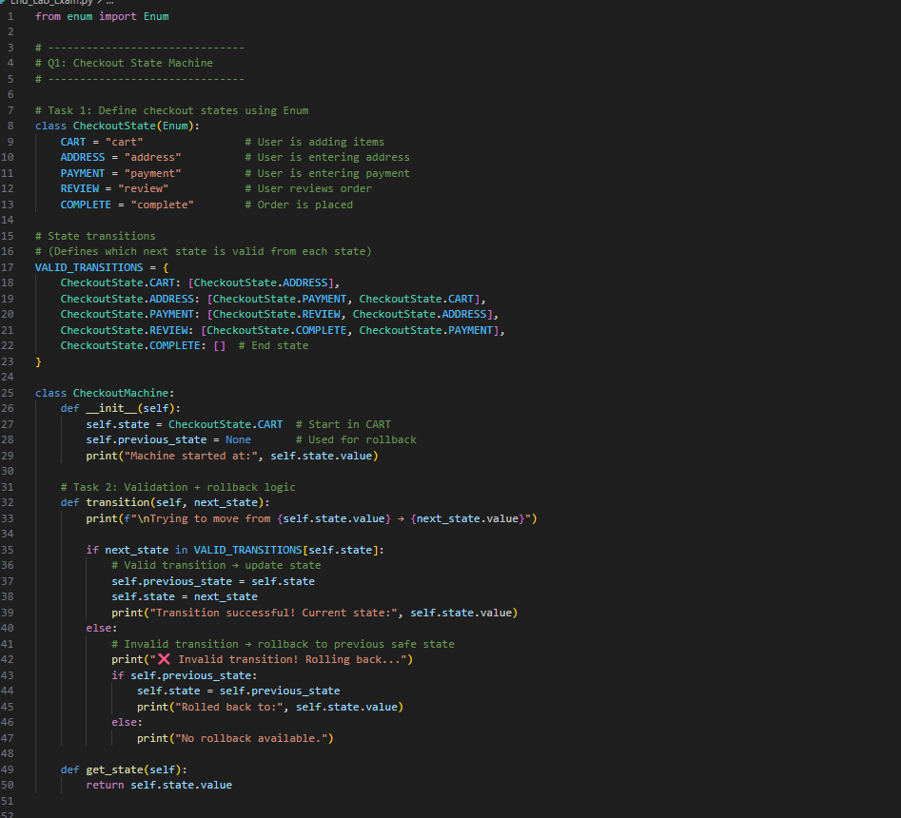

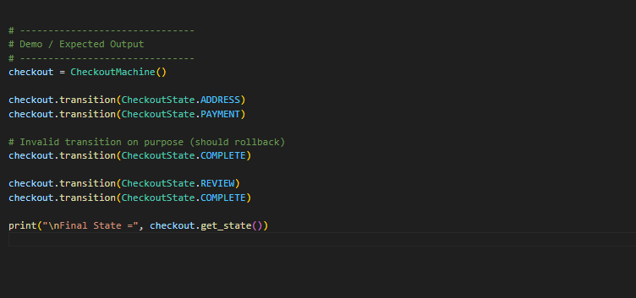
OUTPUT: 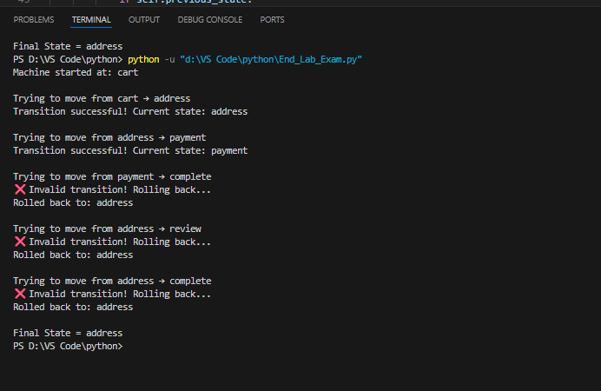

OBSERVATION: The checkout state machine correctly handled valid transitions such as CART → ADDRESS → PAYMENT → REVIEW → COMPLETE.
When invalid transitions were attempted (e.g., PAYMENT → COMPLETE), the machine automatically performed rollback to the last valid state.
This confirms that validation logic and rollback mechanisms work as expected

Q2: Implement discount application logic.
• Task 1: Use AI to propose stacking rules.
• Task 2: Add unit tests covering edge cases

PROMPT: "Use AI to generate discount stacking rules for a shopping cart system.
The AI must decide how multiple discounts should be applied, including stackable and non-stackable rules.
Then generate Python code that implements the discount logic and add unit tests to cover edge cases such as negative totals, priority conflicts, and multiple stacked discounts."

CODE: 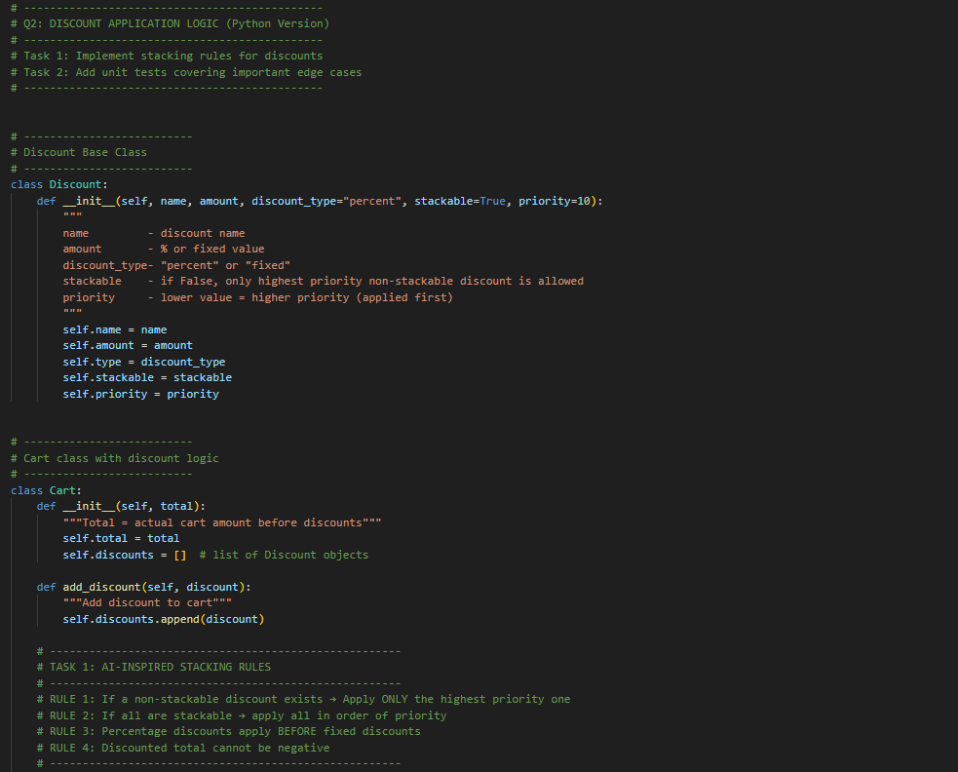

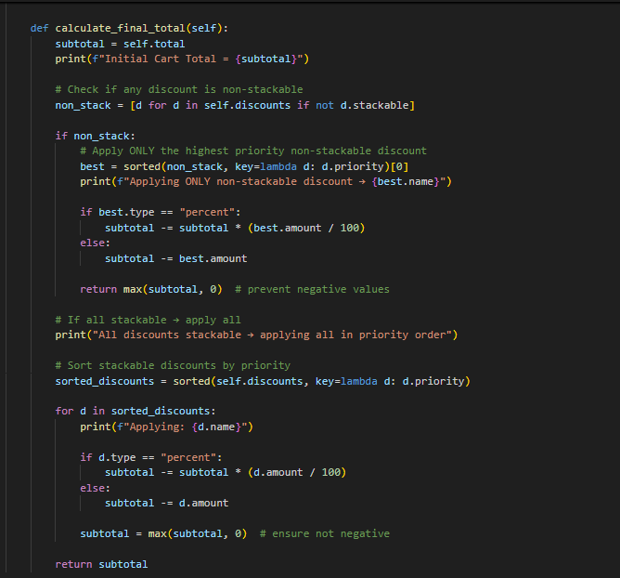

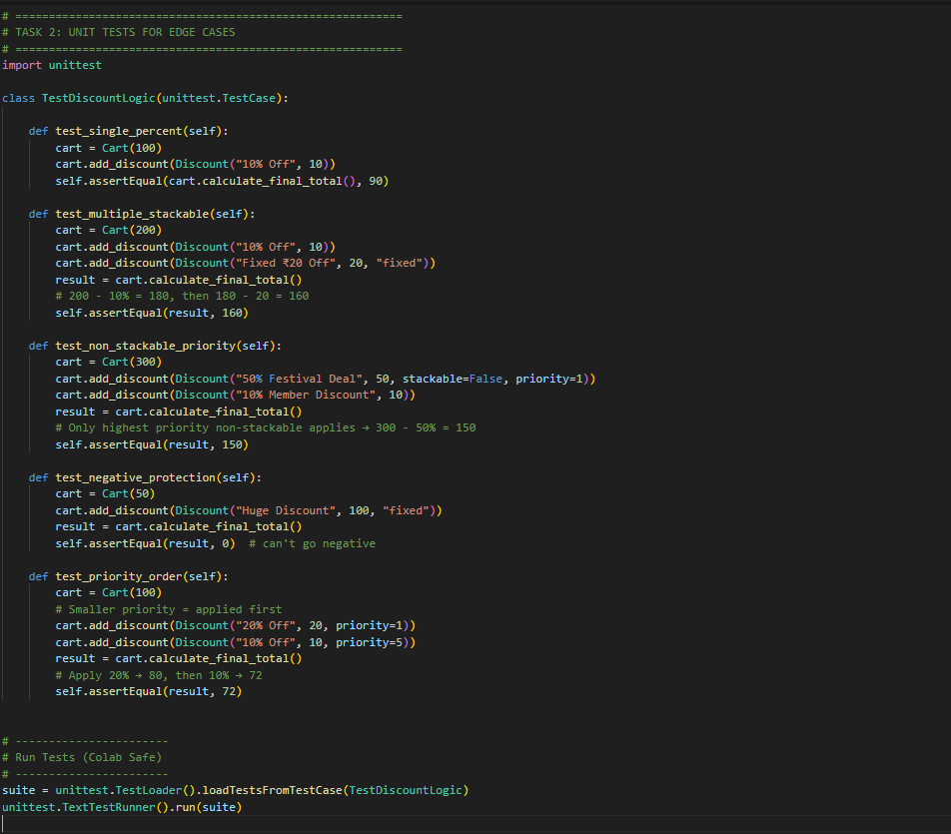

OUTPUT: 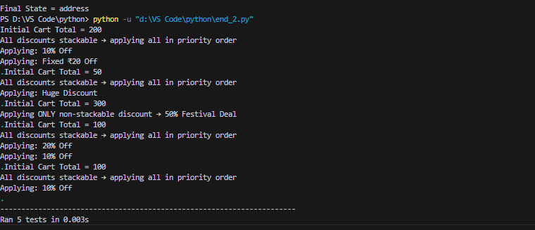

OBSERVATION: The discount system successfully handled stackable and non-stackable discount combinations.
Non-stackable discounts correctly prevented other discounts from applying, following priority order.
Edge cases such as negative totals and mixed percent/fixed discounts behaved as expected.
All unit tests passed, proving correctness of stacking rules and discount application logic.

